OKLAHOMA DEPARTMENT OF REHABILITATION SERVICES
DRS Communications Team’s Report
April 13, 2020

25th People with Disabilities Awareness Day – March 10, 2020
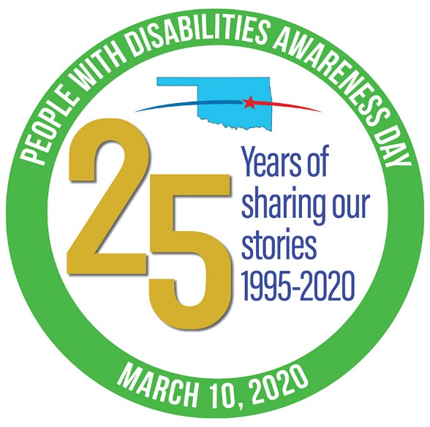
The first big challenge in 2020 for the Communications Team was recreating and rebranding DRS’ 25th annual People with Disabilities Awareness Day. PWDAD normally attracts 900 participants and 76 exhibitors, and is believed by Capitol staff to be the largest annual event at the state Capitol. DRS’ event was in jeopardy due to construction, which prohibited reserving all the space we needed.

Telling our stories has always been the most powerful way for the disability community to engage and inform elected leaders and move them to action on critical disability issues. So we decided to “go mobile” and connect with legislators from wherever we were by phone, email, letters, social media and visits by individuals using what we now call “social distancing.” Communications Administrative Technician Rachel McLemore wrote an impressive letter to her legislators, that we used as an online sample. Plus, Rachel got an appointment!

The Communications Team developed a new #PWDAD2020 platform and strategy. Communications Manager Dana Tallon designed a new website. Communications Officer Brett Jones created a menu of hew communications tools. Dana created five PWDAD videos and Brett created one. Dana scheduled Facebook and Twitter posts to hit every 30 minutes from 10 a.m. to 5 p.m. to mobilize online participants. We also coordinated two traditional PWDAD events at the Capitol on March 10: the DRS awards ceremony and volunteer visits to 101 legislators, the governor and lieutenant governor.

Hosting the online event may have saved 900 on-site participants from possible exposure to the COVID-19 pandemic.

COVID-19 Pandemic and Telework - March 13 – April 13, 2020

Before we could unpack the PWDAD boxes, COVID-19 exploded with the first media inquiry on March 13th and a DRS Executive Team meeting on March 16th to plan the agency’s response. On March 16th, Jody Harlan responded to media inquiries about Oklahoma School for the Blind and Oklahoma School for the Deaf shutting down operations initially until April 6. Eventually the schools moved to distance learning along with other public schools for the rest of the 2019-20 school year.

The Communications Team transitioned with the rest of DRS staff to telework in the middle of March. Customer Service Representative Brett Freeman is responding to calls to the DRS State Office from an agency cell phone and providing many callers with cell phone information for teleworking DRS staff.

Brett F. had several suggestions that helped Jody write a comprehensive DRS Telework, Building Closures and Event Cancellations message for the DRS web site and social media.

This is one of the 62 memes submitted to the DRS CORVID-19 Meme Contest.

Jody’s priorities shifted to analyzing COVID-19 information, writing summaries for DRS leadership, staff and the public, and responding to requests for information generated in in two daily teleconferences (Saturdays and Sundays too) led by the Health and Human Services Cabinet Secretary Justin Brown and the Virtual Joint Information Center team. JIC involved Governor Kevin Stitt’s office, OK State Department of Health, Oklahoma Management and Enterprise Services and approximately 50 state communications directors representing their agencies.

Jody also summarized the content for DRS leadership of five streamed teleconferences by the governor and municipal mayors.

During a JIC meeting, Jody asked if state employees could get access to Facebook again so that they could watch Gov. Stitt’s Facebook Live press conferences on COVID-19. (Facebook access was blocked for most state employees In October 2019. The Communications Team received an exception.) The request to restore statewide access was granted the next day, although some DRS employees may still be blocked due to division or school restrictions.

COVID-19 and Accessibility

Jody advocated for DRS at the JIC teleconferences and with individuals about making state COVID-19 communications fully accessible for Oklahomans with disabilities. The governor’s office passed along our recommendations asking TV stations to frame their shots so sign language interpreters are visible and not blocked by chat boxes on the screen. OK State Department of Health announced at a JIC teleconference that the Americans with Disabilities Act required agencies to use interpreters and provided hiring information. Meanwhile, DRS Vocational Rehabilitation Specialist Jimmy Mitchell became a media and social media “star” for his Deaf Interpreter skills at the governor’s press conferences.

Communications Administrative Assistant Cathy Martin translates OK State Department of Health COVID-19 memes so Jody can post them with alternate text on the DRS web site, social media and emails to DRS staff. (The original graphics are jpegs or traditional pdf files, which are not accessible to screen reading software used by blind people.) Dana Tallon prepared basic instructions to help JIC partners create accessible pdf documents. Jody talked with ABLETech expert Rob Carr, who advises the Governor’s office on accessibility, regarding possible document accessibility solutions.

Meme Contest

On March 18, Jody launched a meme contest encouraging teleworking DRS staff to submit memes for a competition intended to boost morale. Sixty-two staff responded to date. Brett Jones emails one meme to staff every day (like the Beatles meme on this report) and will conduct contest voting through “Breaking Barriers.”
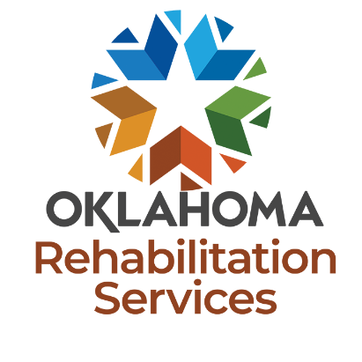
State of Oklahoma Branding Campaign

Dana Tallon created a new profile design for Facebook, Twitter and YouTube to show cooperation with the State of Oklahoma’s new branding campaign launched on February 12. We developed a DRS rebranding campaign plan based on state guidelines with recommendations for a smooth transition. Projects include a new DRS logo, email signature, letterhead, envelopes and other collateral materials.

Conference Rooms Renovation

Dana Tallon, assisted by Brett Jones, created designs, recommended signage, and color palettes, and cooperated with DRS Management Services to complete renovations in the second floor conference room. Designs are finished and painting is done in the fifth floor lobby and conference room. We are waiting to purchase signage in fiscal year 2021.

Census 2020

Jody continues to post Census information on social media and emails DRS staff to encourage participation. Dana Tallon worked with Tiffany Davis from DRS Process Improvement and OK Commerce to create a large print Census poster and a braille-ready file to post in DRS offices. Cathy Martin brailled the documents and distributed the packets.

Publications

Brett Jones publishes the DRS internal, online newsletter “Breaking Barriers” every two weeks and is redesigning “Introduction to DRS,” our publication about all DRS divisions and schools, and Business Services Program Western Region brochure. The Transition brochure for parents is complete. Brett assisted Renee Sansom with the Transition folder update in cooperation with Oklahoma State Department of Education.

DRS Website

Dana Tallon is perfecting DRS website’s mobile presence to ensure that the mobile display is responsive and attractively styled. She continues to update the content of the DRS website and ensures that it sets the standard for website accessibility.

Oklahoma News Target

Cathy Martin chooses print and broadcast media stories about state agency and legislative topics for DRS’ daily “OK News Target.” Cathy also processes and maintains a library of news stories about DRS on a daily basis.

DRS Success Stories

Cathy maintains DRS’ consumer success stories database for Vocational Rehabilitation and Services to the Blind and Visually Impaired. This year, OK School for the Blind and OK School for the Deaf students have a form for their successes so DRS can distribute more stories to state legislators and the Congressional delegation.

Disability Resource Guide

Rachel is contacting more than 3,000 state and community organizations to update their information in the DRS Disability Resource Guide, an online, fully accessible resource for DRS staff and the public at http://www.okdrs.gov/guide/home. The Guide is listed as a COVID-19 resource on the Virtual Joint Information Center web site at https://officemgmtentserv.sharepoint.com/sites/extranet/OKVJIC.

